Execute the script shown in the video.
i) Terraform Remote State and State Locking
Step 1: Create your project directory and configuration file
Open your Mac Terminal and create a dedicated workspace folder for this task:
Bash
mkdir -p terraform-remote-demo
cd terraform-remote-demo
Terraform
provider "aws" {
region = "us-east-1"
}

# 1. Create S3 Bucket to store the state file remotely
resource "aws_s3_bucket" "s3_bucket" {
bucket = "s3backend-pradeep-demo" # Note: S3 bucket names must be globally unique across AWS
}

resource "aws_s3_bucket_acl" "bucket_acl" {
bucket = aws_s3_bucket.s3_bucket.id
acl = "private"
}

# 2. Create DynamoDB Table to handle state locking
resource "aws_dynamodb_table" "dynamodb-terraform-state-lock" {
name = "terraform-state-lock-dynamo"
hash_key = "LockID"
read_capacity = 20
write_capacity = 20

attribute {
name = "LockID"
type = "S"
}
}

Step 2: Initialize and apply to create backend resources in AWS
Run the following commands in your terminal to initialize Terraform and provision the S3 bucket and DynamoDB table:
Bash
terraform init
terraform apply

Type yes when prompted to confirm the creation. Once finished, AWS has your storage and locking infrastructure ready.

Step 3: Configure the Remote Backend Block
Now that your S3 bucket and DynamoDB table exist, configure Terraform to store its state file remotely inside them and enable state locking.
Update your main.tf file to add the terraform { backend "s3" { ... } } block:
Terraform
terraform {
required_version = ">= 1.0.0"

backend "s3" {
bucket = "s3backend-pradeep-demo" # Must match your exact S3 bucket name
dynamodb_table = "terraform-state-lock-dynamo"
key = "terraform.tfstate"
region = "us-east-1"
}

required_providers {
aws = {
source = "hashicorp/aws"
version = "~> 5.0"
}
}
}

provider "aws" {
region = "us-east-1"
}

# Keep your resource definitions below
resource "aws_s3_bucket" "s3_bucket" {
bucket = "s3backend-pradeep-demo"
}

resource "aws_s3_bucket_acl" "bucket_acl" {
bucket = aws_s3_bucket.s3_bucket.id
acl = "private"
}

resource "aws_dynamodb_table" "dynamodb-terraform-state-lock" {
name = "terraform-state-lock-dynamo"
hash_key = "LockID"
read_capacity = 20
write_capacity = 20

attribute {
name = "LockID"
type = "S"
}
}

Step 4: Migrate your local state to the remote S3 backend
Run terraform init again to apply the new backend configuration:
Bash
terraform init

Terraform will detect that you have introduced a remote backend configuration and will output a prompt asking:
"Do you want to copy existing state to the new backend?"
Type yes and press Enter. Terraform will safely migrate your local terraform.tfstate file up into your AWS S3 bucket.

Step 5: Verify the Remote State and Locking
- Verify S3 State Storage: Log into your AWS S3 Console, click into your s3backend-pradeep-demo bucket, and you will see the terraform.tfstate file stored there. Your local terraform.tfstate file is no longer needed locally.
- Test State Locking: If you open a second terminal window, navigate to the same folder, and run terraform apply while another operation is running, DynamoDB will automatically throw a lock error indicating that the state file is currently locked by an active process, preventing concurrent overwrites.

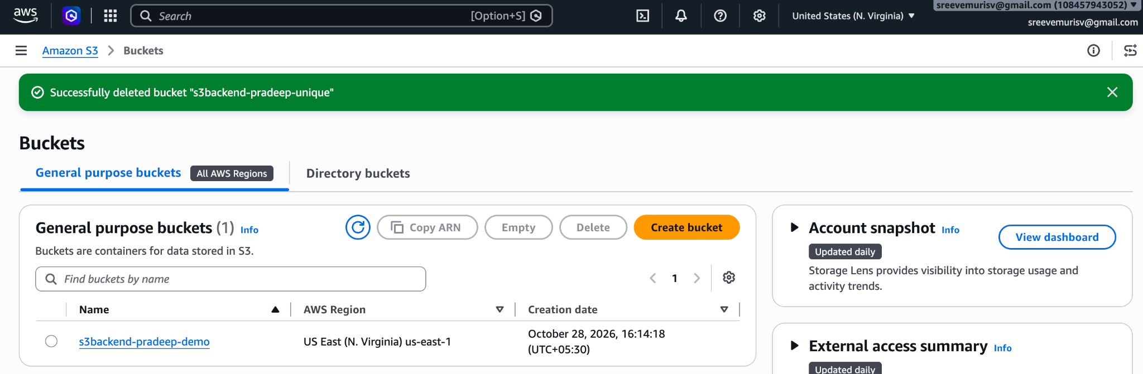

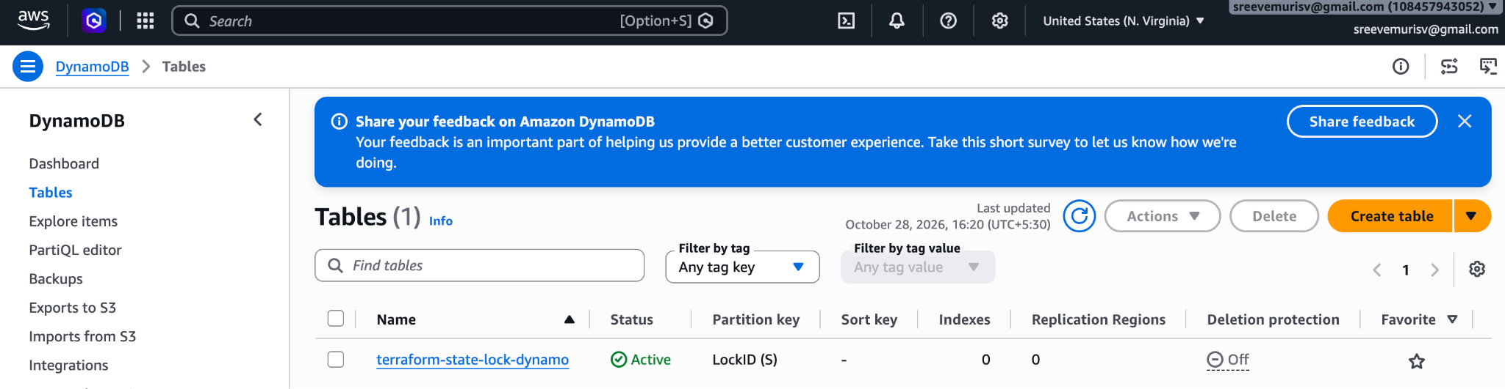

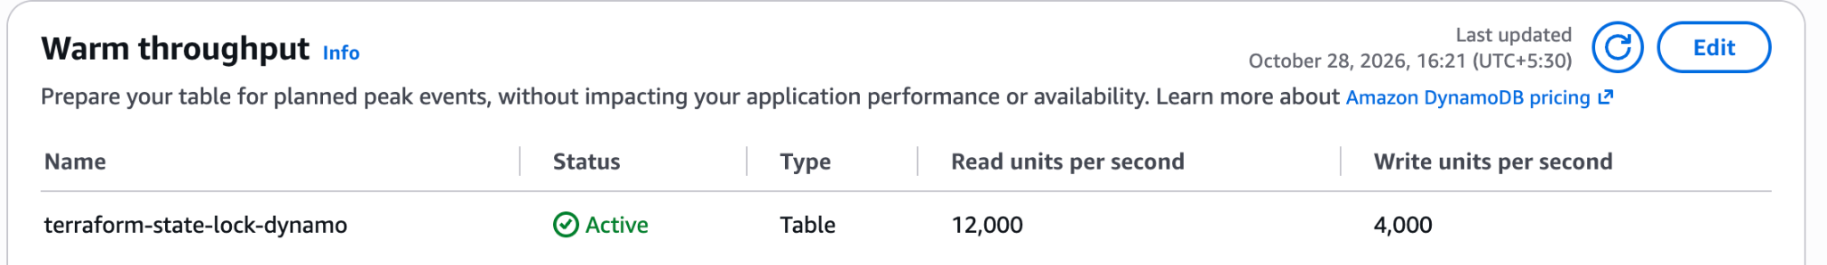

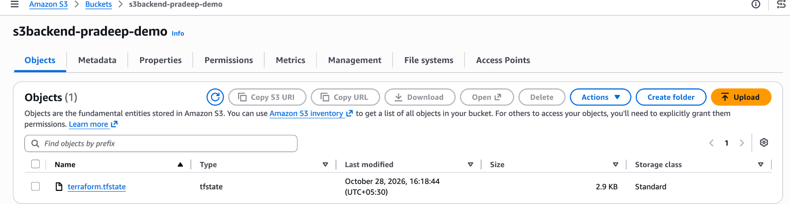
ii) Terraform Taint and Untaint

Part 1: What is the Difference Between Taint and Untaint?
Command | Action Performed | What happens on next terraform apply?
terraform taint | Manually marks a specific resource as degraded, broken, or out-of-sync in the local state file. | Terraform treats the resource as destroyed and forces it to be deleted and recreated from scratch.
terraform untaint | Reverses the tainted status, returning the resource back to its normal, healthy state. | Terraform cancels the scheduled destruction/recreation; the resource is left completely untouched.

Part 2: When and Where to Use It?
- When a resource configuration fails halfway: If a provisioning script or configuration crashes during creation, Terraform automatically marks that resource as tainted so it can clean up the broken state on the next run.
- When manual changes are made outside of Terraform: If an engineer manually logs into AWS and modifies an EC2 server (e.g., deletes core packages, messes up configurations, or breaks dependencies), Terraform won't automatically notice if the code looks the same. By running terraform taint, you force Terraform to throw away the broken instance and spin up a fresh, clean replacement.

Part 3: Step-by-Step Code and Execution Guide

Step 1: Create your project directory and configuration file
Open your Mac Terminal and run:
Bash
mkdir -p terraform-taint-demo
cd terraform-taint-demo

Create a main.tf file using your text editor and add the following code:
Terraform
provider "aws" {
region = "us-east-1"
}

resource "aws_instance" "webserver" {
ami = "ami-02f3f602d23f1659d" # Amazon Linux 2023 AMI (us-east-1)
instance_type = "t2.micro"

tags = {
Name = "Taint-Demo-Server"
}
}

Step 2: Initialize and apply the configuration
Initialize your working directory and provision the EC2 instance:
Bash
terraform init
terraform apply

Type yes when prompted. Note down or verify that the EC2 instance is successfully created.

Step 3: Use terraform taint
Imagine something went wrong with this server manually, or you want to force Terraform to rebuild it on the next run. Run the taint command referencing the resource type and name (aws_instance.webserver):
Bash
terraform taint aws_instance.webserver

What you will see in the terminal:
Resource instance aws_instance.webserver has been marked as tainted.
If you run terraform plan right now, Terraform will explicitly state that it plans to destroy and recreate (-/+) the instance.

Step 4: Use terraform untaint (Optional Reversal)
If you change your mind and decide you do not want to destroy and recreate the resource after all, you can undo the taint status:
Bash
terraform untaint aws_instance.webserver

What you will see in the terminal:
Resource instance aws_instance.webserver has been successfully untainted.
If you run terraform plan now, the plan will change back to "No changes. Infrastructure is up-to-date."
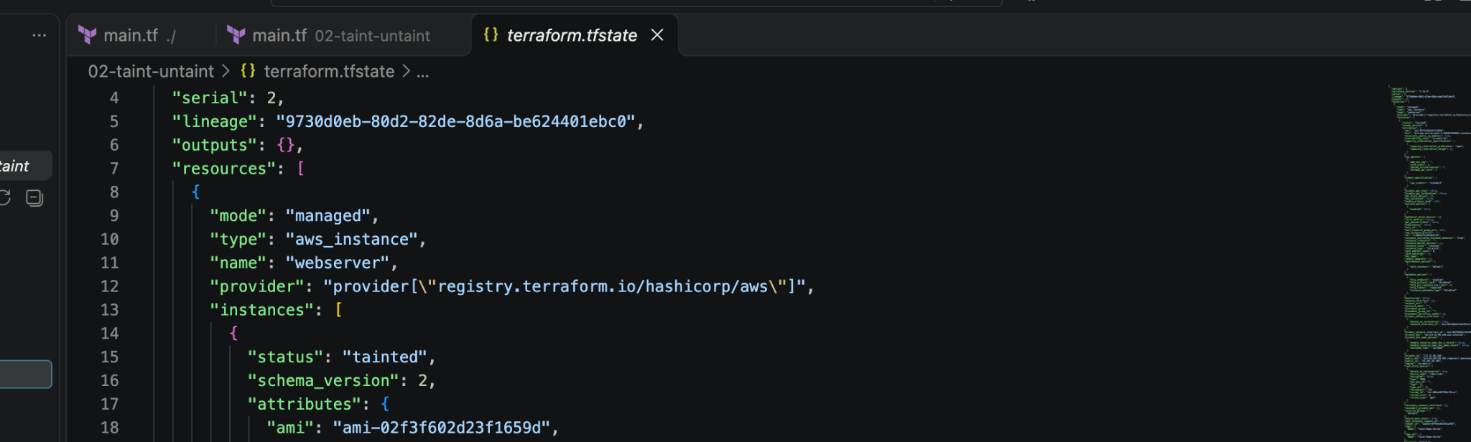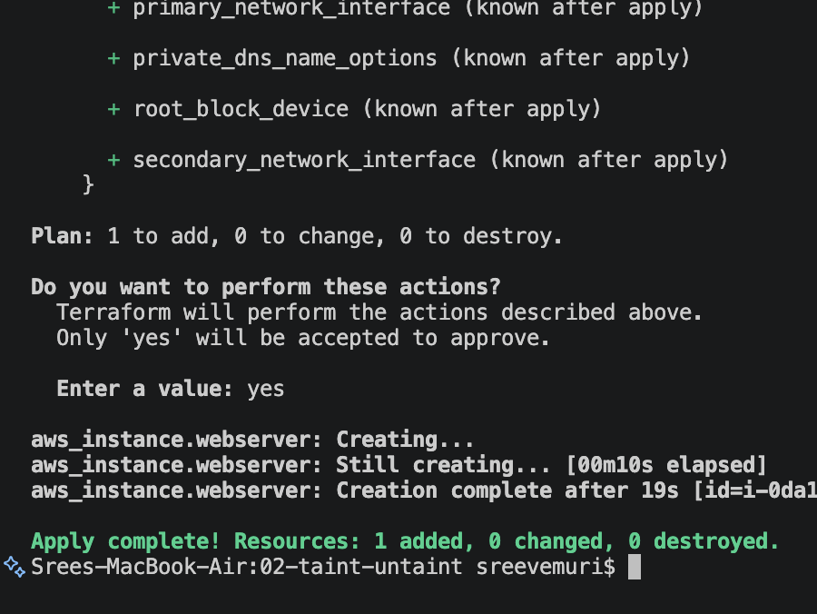
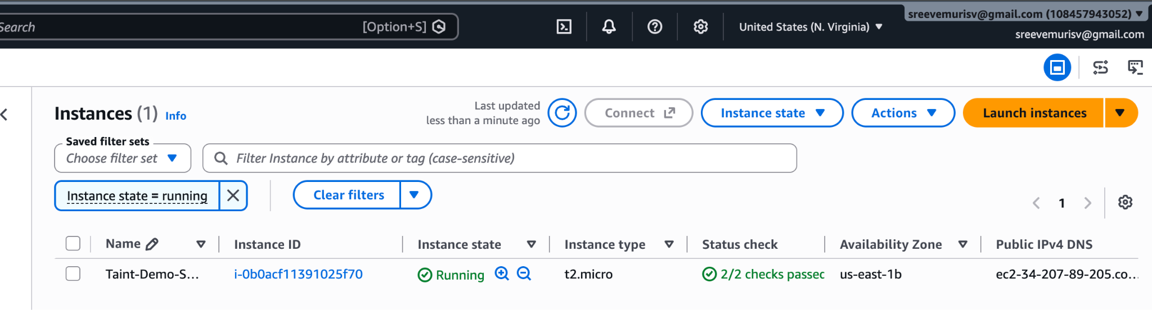
iii) Here is the clean, step-by-step documentation for Task 3: Debugging in Terraform, optimized for your Mac terminal (macOS Zsh shell).

Task 3: Terraform Debugging Guide
When troubleshooting Terraform errors that go beyond standard error messages, you can enable verbose logging using environment variables.

1. Understanding the 5 Log Levels
Terraform supports five logging levels, ranging from general messages to maximum verbosity:

- INFO — General execution information.

- WARNING — Non-critical alerts (e.g., deprecated features).

- ERROR — Critical failures where operations halt.

- DEBUG — Detailed technical information and internal states.

- TRACE — Maximum verbosity. Captures every underlying API call, response payload, and function trace.

2. Enabling Trace Logging on macOS
Open your terminal and set the log level using the export command:

Bash
export TF_LOG=TRACE

3. Redirecting Logs to a Permanent File
Since TRACE logging generates a massive volume of output, it is best practice to save the logs to a persistent file so your terminal screen does not get flooded:

Bash
export TF_LOG_PATH=/tmp/terraform.log

4. Running Your Terraform Commands
Once the environment variables are set, run your normal Terraform commands (e.g., plan or apply):

Bash
terraform apply

Your terminal screen will stay clean while all diagnostic data writes in real-time to /tmp/terraform.log.

5. Viewing and Searching Logs
If you need to analyze the log file or look for specific error codes, you can view or search it using standard Unix commands:

Bash
# Tail the logs in real-time in another terminal window
tail -f /tmp/terraform.log

# Search for specific errors or keywords
grep -i "error" /tmp/terraform.log

6. Disabling / Unsetting Logs
When you are finished troubleshooting, remember to unset the logging variables to stop generating log files:
Bash
unset TF_LOG
unset TF_LOG_PATH

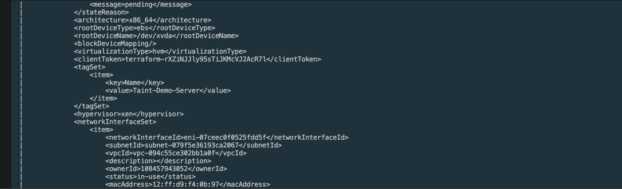

iv) Import
Here is the complete documentation and step-by-step guide for Task 4: Terraform Import, optimized for your Mac environment.

Task 4: Terraform Import Guide

1. What is Terraform Import?
terraform import is used to bring existing, manually created infrastructure (resources that were created outside of Terraform, such as through the AWS Console, CLI, or another tool) into your Terraform state file.

- Why use it? If you already have running resources in AWS and want Terraform to start managing, updating, or deleting them without recreating them from scratch, you import them.

- Important Note: terraform import does not automatically write the HCL configuration code for you. You must write the resource block configuration yourself first, and then import the actual ID to link it to your state.

Step-by-Step Implementation

Step 1: Create a project directory for Import
Open your Mac Terminal and create a dedicated workspace:

Bash
mkdir -p terraform-import-demo
cd terraform-import-demo

Step 2: Create a manual resource in AWS (Prerequisite)
For testing this out, you can manually spin up an EC2 instance directly in your AWS Console (or use an existing instance ID if you have one running, e.g., i-0123456789abcdef0). Let's assume your target instance ID is i-0abcdef123456789.

Step 3: Write the matching resource configuration
Create a main.tf file and write an empty or basic resource shell matching the type of resource you want to import:

Terraform
provider "aws" {
region = "us-east-1"
}

# The resource name and type must match what you intend to import
resource "aws_instance" "imported_server" {
ami = "ami-02f3f602d23f1659d" # Match the AMI of the existing instance
instance_type = "t2.micro" # Match the instance type

tags = {
Name = "Imported-Server"
}
}

Step 4: Initialize Terraform
Run initialization to download the necessary AWS provider plugins:

Bash
terraform init

Step 5: Execute the Import Command
Run the import command using the syntax:terraform import <resource_type>.<resource_name> <aws_resource_id>

Bash
terraform import aws_instance.imported_server i-0abcdef123456789

Replace i-0abcdef123456789 with your actual EC2 instance ID from AWS.

What you will see in the terminal:

aws_instance.imported_server: Importing from ID "i-0abcdef123456789"...
aws_instance.imported_server: Import successful!
Command successful! The imported resources are indicated above...

Step 6: Verify the State Match
Run terraform plan to ensure that Terraform successfully recognizes the imported resource and that your configuration file matches what is currently running in AWS:

Bash
terraform plan

If your configuration matches the live resource properties, Terraform will output:

“No changes. Your infrastructure matches the configuration.”
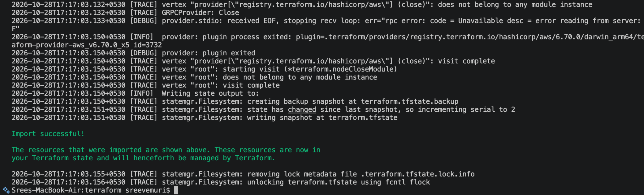
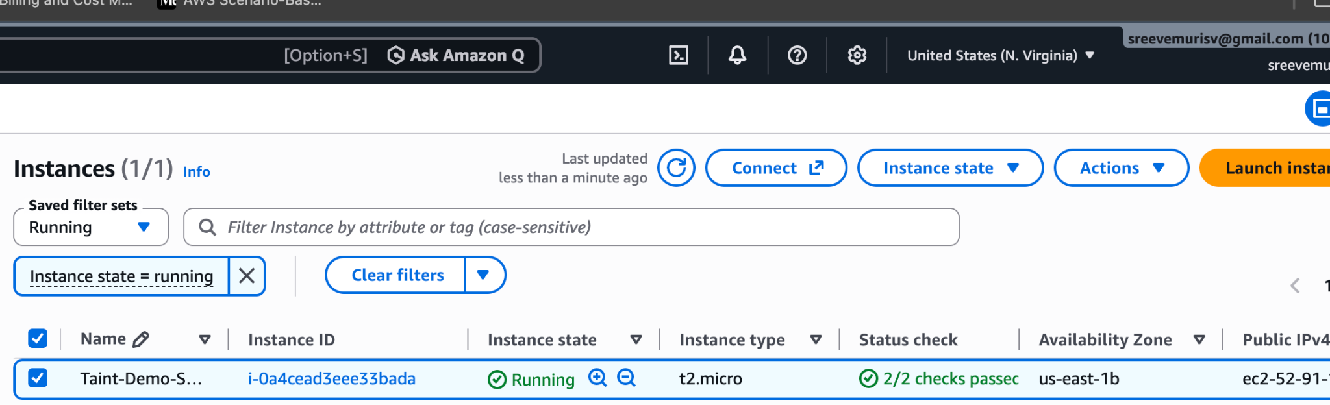
3)

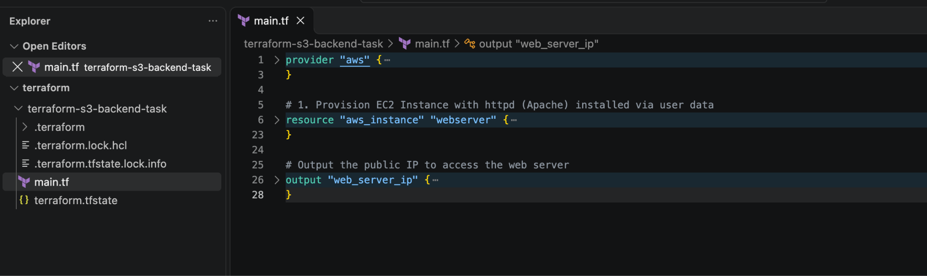
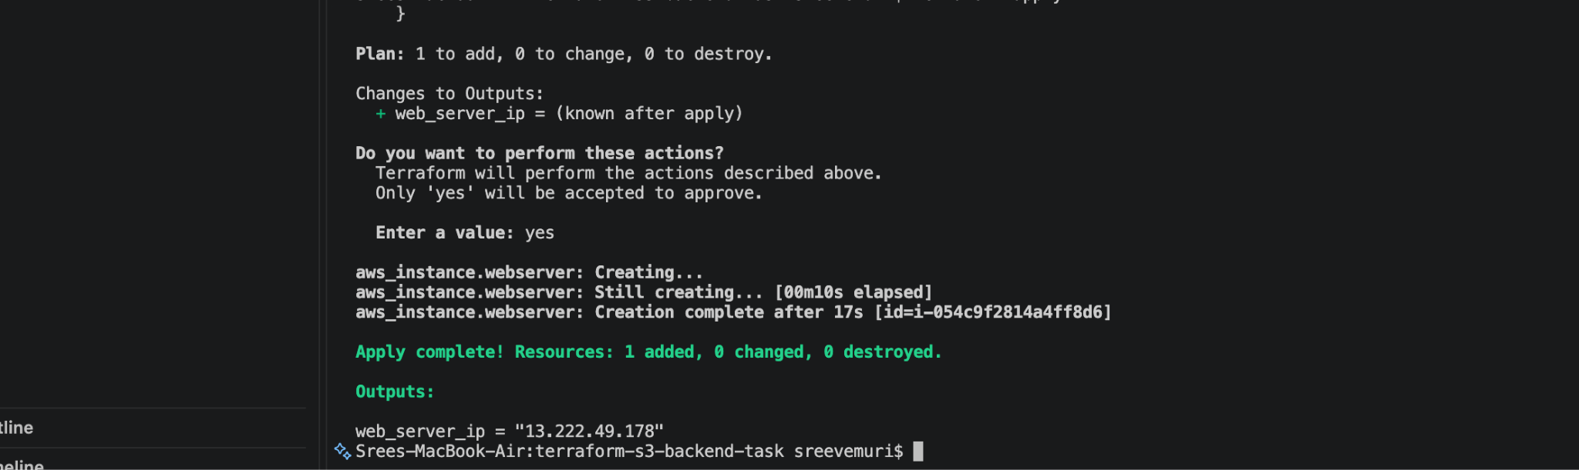
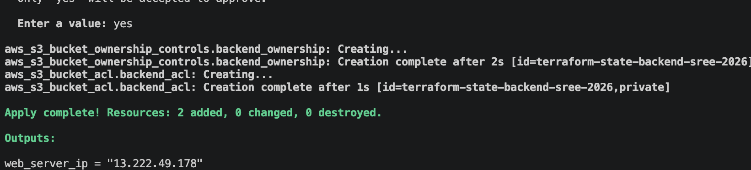

================================================================================
AWS INFRASTRUCTURE AUTOMATION & S3 BACKEND DOCUMENTATION
================================================================================

1. PROJECT OVERVIEW
--------------------------------------------------------------------------------
This document details the step-by-step implementation of an automated cloud architecture on Amazon Web Services (AWS) using HashiCorp Terraform. The primary objective is to provision an EC2 web server running Apache while storing the Terraform state file securely in a remote Amazon S3 backend with DynamoDB locking.

2. ARCHITECTURE COMPONENTS & RESOURCE DEFINITIONS
--------------------------------------------------------------------------------
The infrastructure is defined as code within a single configuration file (main.tf) comprising four major components:

A. Amazon S3 Backend (State Storage)
- Code Definition: Defined using the `aws_s3_bucket` resource and configured in the `terraform { backend "s3" { ... } }` block.
- Bucket Naming: Scoped with the unique AWS Account ID suffix (`terraform-state-backend-sree-108457943052`) to prevent global namespace collisions.
- Purpose: Stores the `terraform.tfstate` file remotely under the key `task1-httpd/terraform.tfstate`, establishing a centralized source of truth.

B. Amazon DynamoDB (State Locking)
- Code Definition: Defined via `aws_dynamodb_table` named `terraform-state-lock-table` with hash key `LockID`.
- Purpose: Prevents concurrent state modifications and race conditions by locking the state during active Terraform operations.

C. Amazon EC2 Web Server & Security Group
- Code Definition: Managed via `aws_instance` (t2.micro using Amazon Linux) and `aws_security_group`.
- Security Group Link: Attached to the instance via `vpc_security_group_ids = [aws_security_group.web_sg.id]`, opening inbound port 80 (HTTP) to all IP addresses (`0.0.0.0/0`).
- Automation Script (user_data): Automatically updates system packages, installs Apache (`httpd`), enables the service on boot, and writes a welcome message to `/var/www/html/index.html`.

3. STEP-BY-STEP DEPLOYMENT PROCEDURE
--------------------------------------------------------------------------------
Because an S3 backend bucket must exist in AWS before Terraform can write state files to it, deployment follows a deliberate two-stage initialization process:

Phase 1: Local Bootstrap
1. Comment out the `backend "s3"` block in your `main.tf`.
2. Run: terraform init -reconfigure
3. Run: terraform apply
(This initializes locally, then provisions the S3 bucket, DynamoDB table, Security Group, and EC2 instance in AWS.)

Phase 2: Remote Migration
1. Uncomment the `backend "s3"` block in your `main.tf`.
2. Run: terraform init -migrate-state
(This links the remote S3 backend and seamlessly uploads your local state file into AWS storage.)

4. COMPLETE INFRASTRUCTURE CONFIGURATION (main.tf)
--------------------------------------------------------------------------------
terraform {
required_version = ">= 1.0.0"

# Uncomment after initial local creation
# backend "s3" {
# bucket = "terraform-state-backend-sree-108457943052"
# dynamodb_table = "terraform-state-lock-table"
# key = "task1-httpd/terraform.tfstate"
# region = "us-east-1"
# }

required_providers {
aws = {
source = "hashicorp/aws"
version = "~> 6.0"
}
}
}

provider "aws" {
region = "us-east-1"
}

# --- Task 1: EC2 Web Server & Security Group Attachment ---
resource "aws_instance" "webserver" {
ami = "ami-02f3f602d23f1659d"
instance_type = "t2.micro"

vpc_security_group_ids = [aws_security_group.web_sg.id]

user_data = <<-EOF
#!/bin/bash
sudo yum update -y
sudo yum install httpd -y
sudo systemctl start httpd
sudo systemctl enable httpd
sudo chmod 755 /var/www/html
echo "<h1>Welcome to Terraform Web Server on AWS!</h1>" | sudo tee /var/www/html/index.html
EOF

tags = {
Name = "Terraform-Httpd-Server"
}
}

output "web_server_ip" {
value = aws_instance.webserver.public_ip
}

# --- Task 2: Unique S3 Backend Storage Resources ---
resource "aws_s3_bucket" "s3_backend" {
bucket = "terraform-state-backend-sree-108457943052"
}

resource "aws_s3_bucket_ownership_controls" "backend_ownership" {
bucket = aws_s3_bucket.s3_backend.id
rule {
object_ownership = "ObjectWriter"
}
}

resource "aws_s3_bucket_acl" "backend_acl" {
depends_on = [aws_s3_bucket_ownership_controls.backend_ownership]
bucket = aws_s3_bucket.s3_backend.id
acl = "private"
}

# --- Task 3: DynamoDB State Locking Resources ---
resource "aws_dynamodb_table" "terraform_lock" {
name = "terraform-state-lock-table"
hash_key = "LockID"
read_capacity = 20
write_capacity = 20

attribute {
name = "LockID"
type = "S"
}
}

# --- Security Group for HTTP Access ---
resource "aws_security_group" "web_sg" {
name = "web-server-http-sg"
description = "Allow HTTP inbound traffic on port 80"

ingress {
description = "Allow HTTP from anywhere"
from_port = 80
to_port = 80
protocol = "tcp"
cidr_blocks = ["0.0.0.0/0"]
}

egress {
from_port = 0
to_port = 0
protocol = "-1"
cidr_blocks = ["0.0.0.0/0"]
}

tags = {
Name = "WebServer-SecurityGroup"
}
}

5. VERIFICATION & ACCESS
--------------------------------------------------------------------------------
1. Retrieve your server's public IP address via terminal output:
terraform output web_server_ip

2. Open a web browser and navigate to `http://<web_server_ip>` to verify that the Apache web server successfully serves the deployment welcome page.


